- Write a query to get a Product list (id, name, unit price) where current products cost less than $20.

Ans.
SELECT ProductID, ProductName, UnitPrice
FROM Products
WHERE (((UnitPrice)<20) AND ((Discontinued)=0))

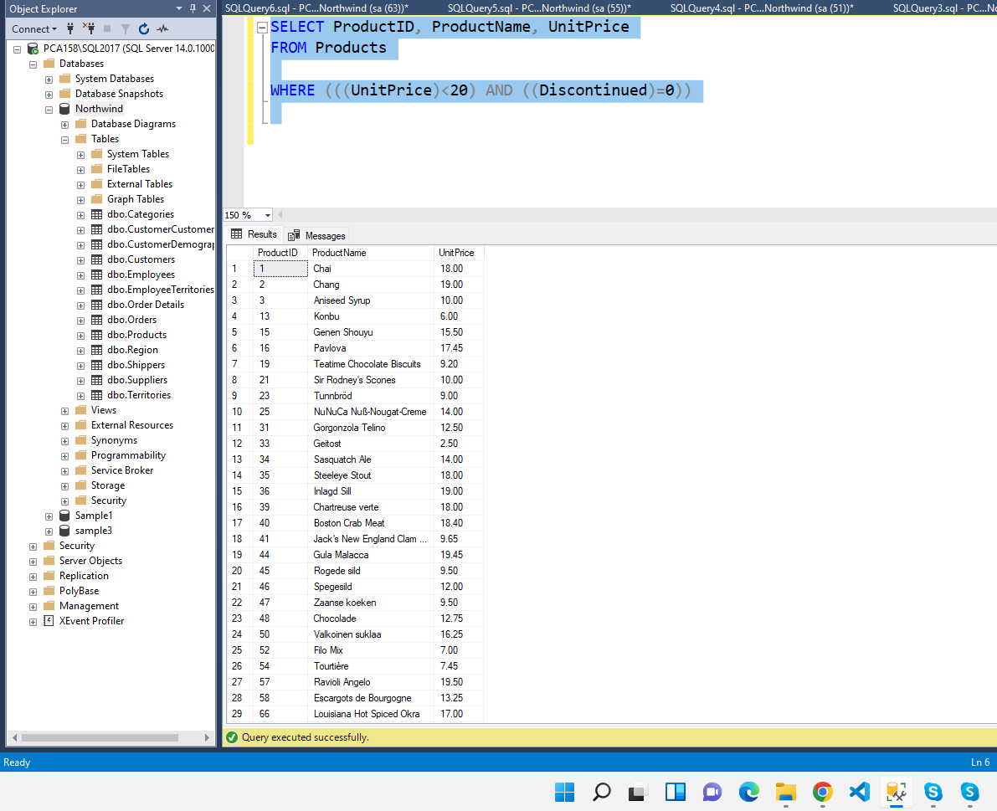

- Write a query to get Product list (id, name, unit price) where products cost between $15 and $25

Ans.

SELECT ProductName, UnitPrice
FROM Products
WHERE (((UnitPrice)>15 And (UnitPrice)<25)
AND ((Products.Discontinued)=0))

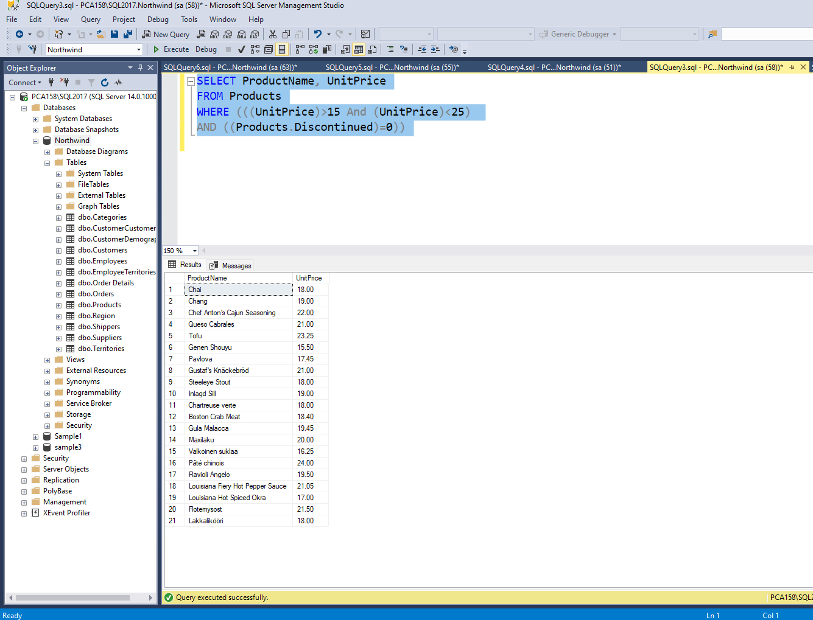

- Write a query to get Product list (name, unit price) of above average price.

Ans.
SELECT DISTINCT ProductName, UnitPrice
FROM Products
WHERE UnitPrice > (SELECT avg(UnitPrice) FROM Products)

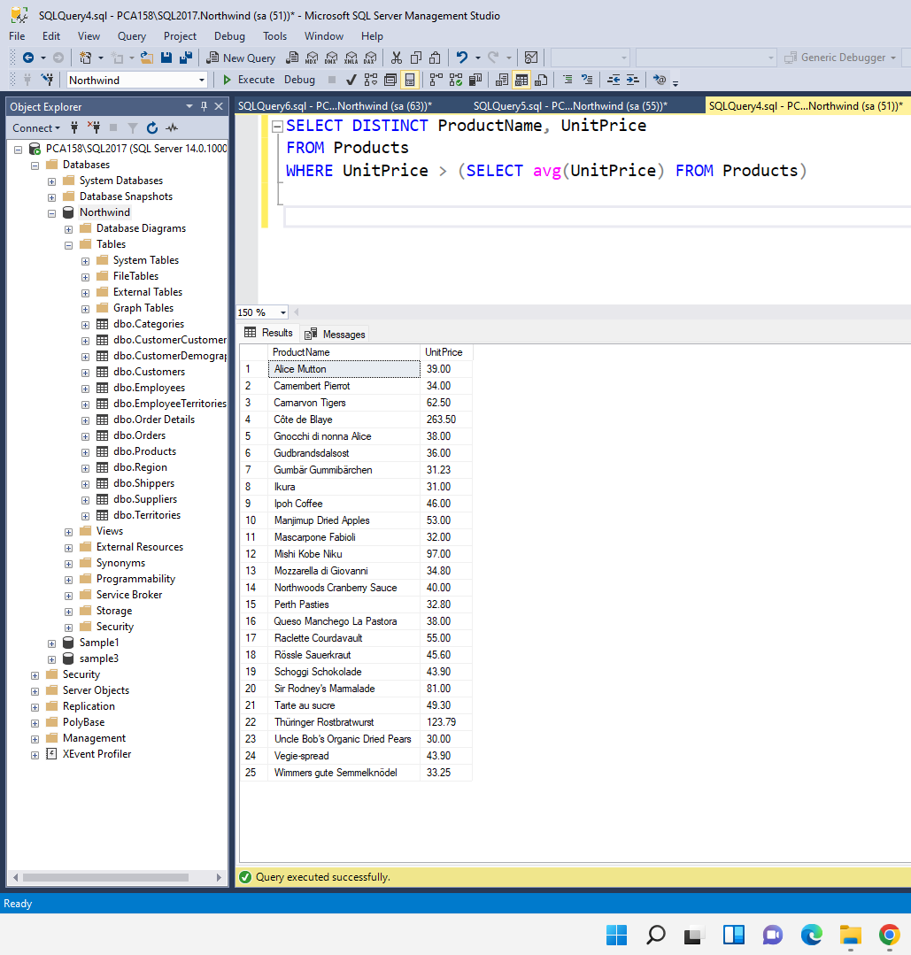

- Write a query to get Product list (name, unit price) of ten most expensive products

Ans.
SELECT DISTINCT ProductName as Ten_Most_Expensive_Products, UnitPrice
FROM Products AS a
WHERE 10 >= (SELECT COUNT(DISTINCT UnitPrice)
FROM Products AS b
WHERE b.UnitPrice >= a.UnitPrice)

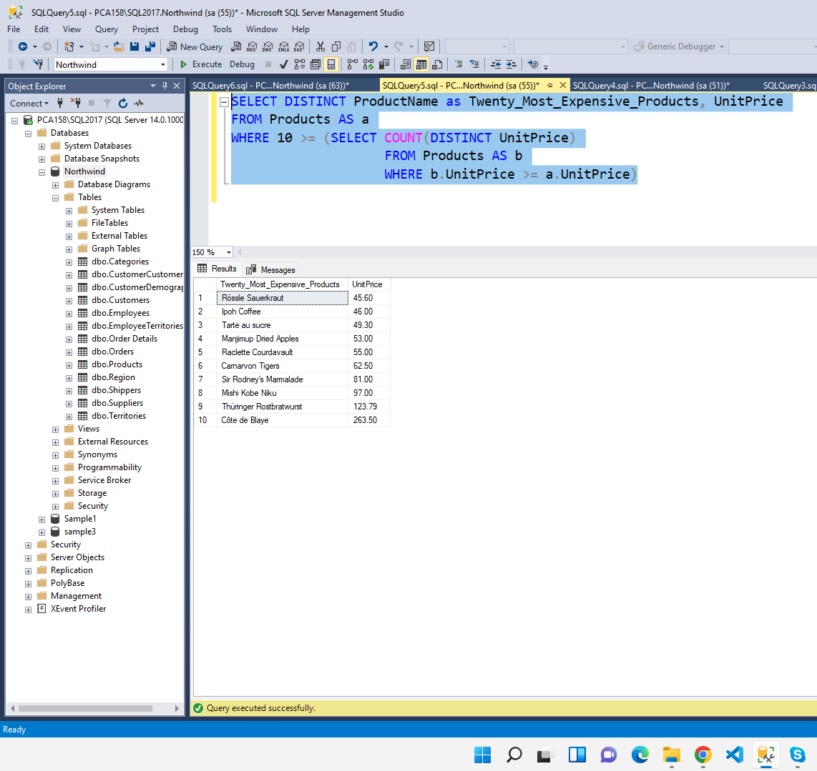

- Write a query to count current and discontinued products

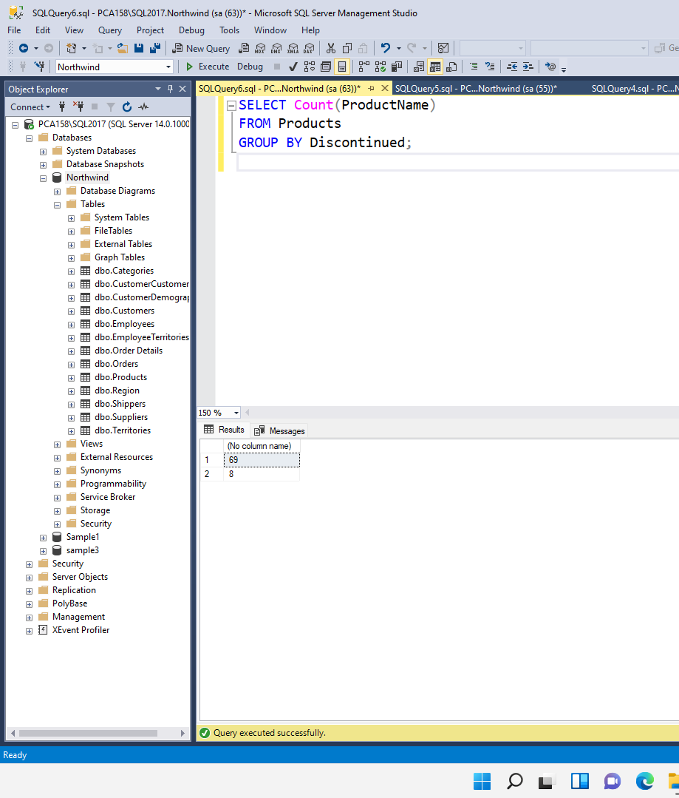
Ans.
SELECT Count(ProductName)
FROM Products
GROUP BY Discontinued;

- Write a query to get Product list (name, units on order , units in stock) of stock is less than the quantity on order

Ans.
SELECT ProductName, UnitsOnOrder , UnitsInStock
FROM Products
WHERE (((Discontinued)=0) AND ((UnitsInStock)<UnitsOnOrder));

